

Directions for Creating a Scratch Teacher Account

Open up your browser and navigate to <https://scratch.mit.edu/>

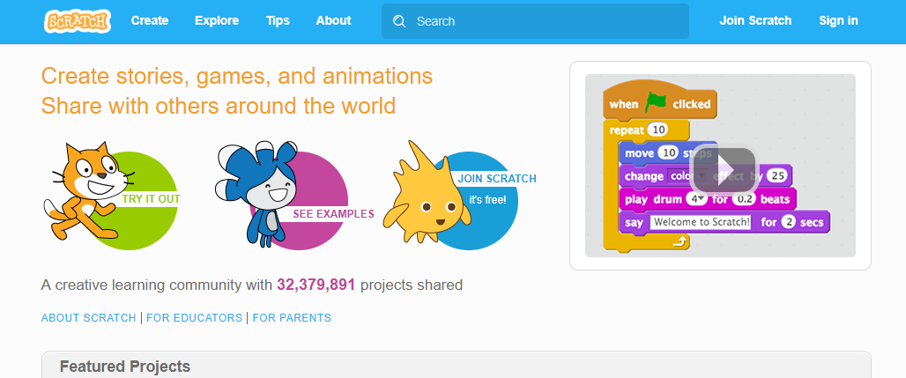

Scroll to the bottom of the page and click on the For Educators link

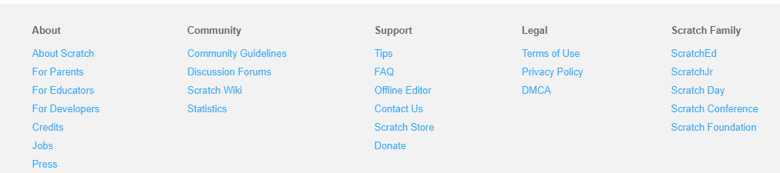

Click on the Teacher Accounts button

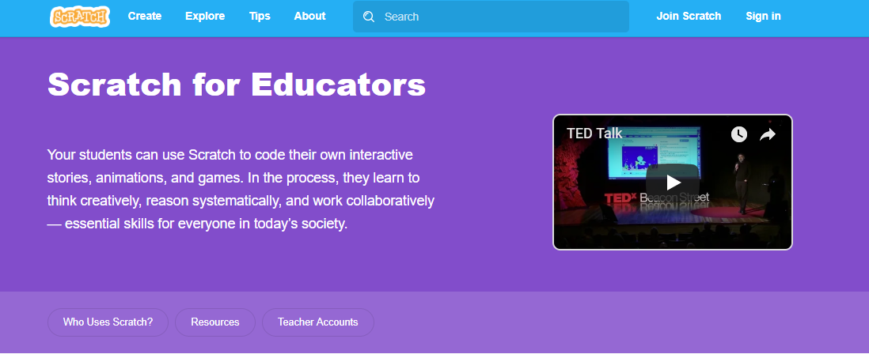  


Click on the Request Account button

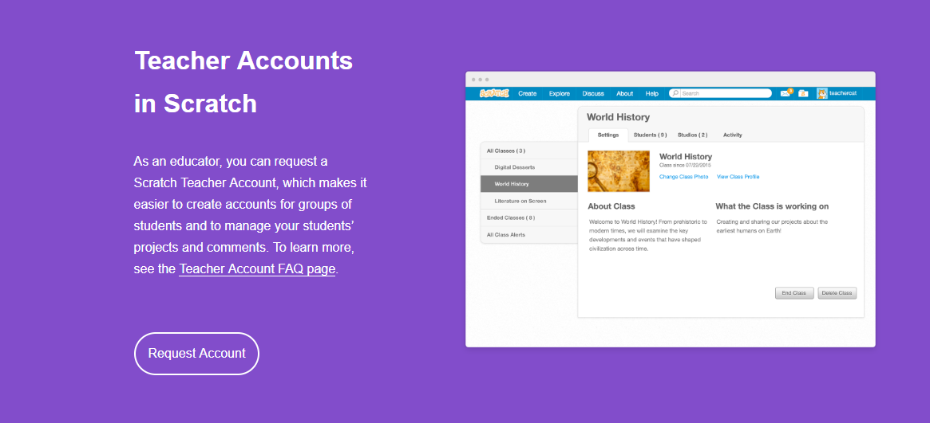  


Go through the wizard to create your account-use your school email address

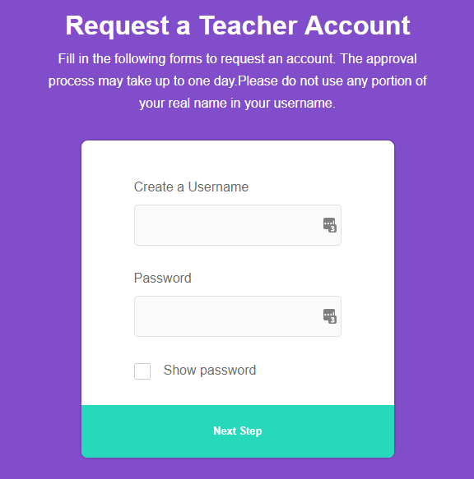

Once you get to the end of the wizard it will tell you that you need to verify your email address. Open your email and click on the link to verify your email address.